1. Recipes- User logs in and creates a profile (either through OAuth or manually input in data) on the web app. The user can then input food items they currently have available (available via ingredients api) and the app will suggest recipes. The recipes suggested require at most the number of ingredients imputed but can also suggest recipes using less ingredients. Using a music api, a playlist will be created with a type of music that goes with the recipe.

<https://rapidapi.com/blog/recipe-apis/>

[Recipe - Food - Nutrition API Documentation (spoonacular) | RapidAPI](https://rapidapi.com/spoonacular/api/recipe-food-nutrition/)

[Spotify API Documentation (Glavier) | RapidAPI](https://rapidapi.com/Glavier/api/spotify23/)

[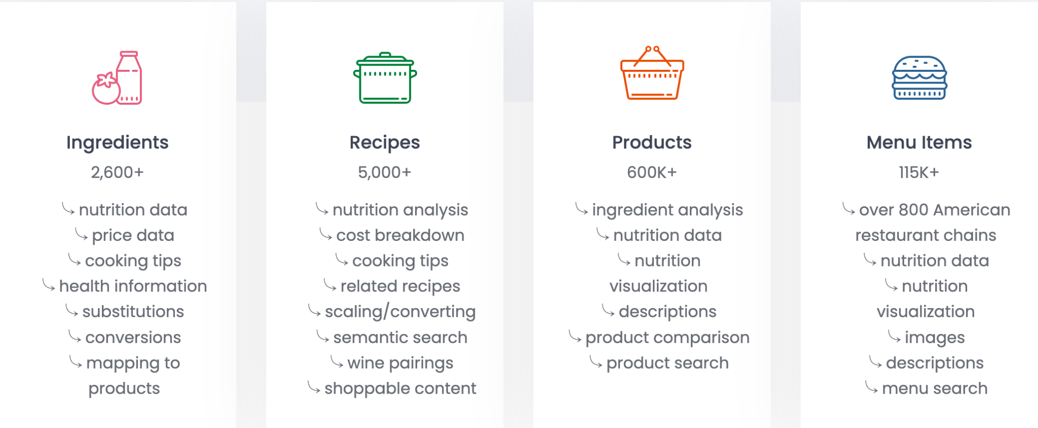](https://rapidapi.com/spoonacular/api/recipe-food-nutrition/)

1. Novel text + translation api - user has to log in first. given a prompt and a language and generate some text and translate to that language. The user will input some general text that they want the program to autocomplete and the open api will generate text using the context that the user provided in the input. Once the new text has been generated the entire text will be passed into the cloud translation api where it will translate it to the user selected language. These will be stored for future reference in their for their user account.
   1. <https://beta.openai.com/docs/guides/completion/introduction>
   2. <https://cloud.google.com/translate> using pretrained model - we do not have nearly enough data to train a model ourselves